Department: BCA

Faculty Name: Er. Ashish Kumar

Subject: Java

Topic: Polymorphism in Java

**Polymorphism in Java**

* Polymorphism is considered as one of the important features of Object Oriented Programming.
* Polymorphism allows us to perform a single action in different ways.
* In other words, polymorphism allows you to define one interface and have multiple implementations.
* The word “poly” means many and “morphs” means forms, So it means many forms.

**In Java polymorphism is mainly divided into two types:**

1. Compile time Polymorphism
2. Runtime Polymorphism
3. **Compile time Polymorphism:** It is also known as static polymorphism. This type of polymorphism is achieved by method overloading or operator overloading.

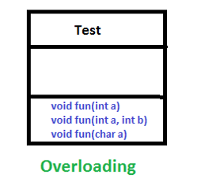

* **method overloading:** Overloading allows different methods to have the same name, but different signatures where the signature can differ by the number of input parameters or type of input parameters or both. Overloading is related to compile-time (or static) polymorphism.

**Example:**

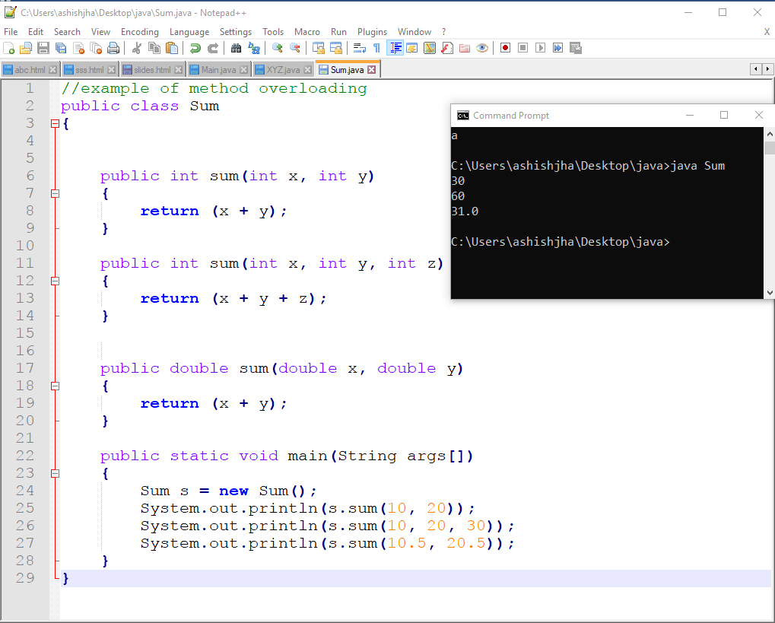

* **Operator Overloading:** Java also provide option to overload operators. For example, we can make the operator (‘+’) for string class to concatenate two strings. We know that this is the addition operator whose task is to add two operands. So a single operator ‘+’ when placed between integer operands, adds them and when placed between string operands, concatenates them. In java, Only “+” operator can be overloaded

Example

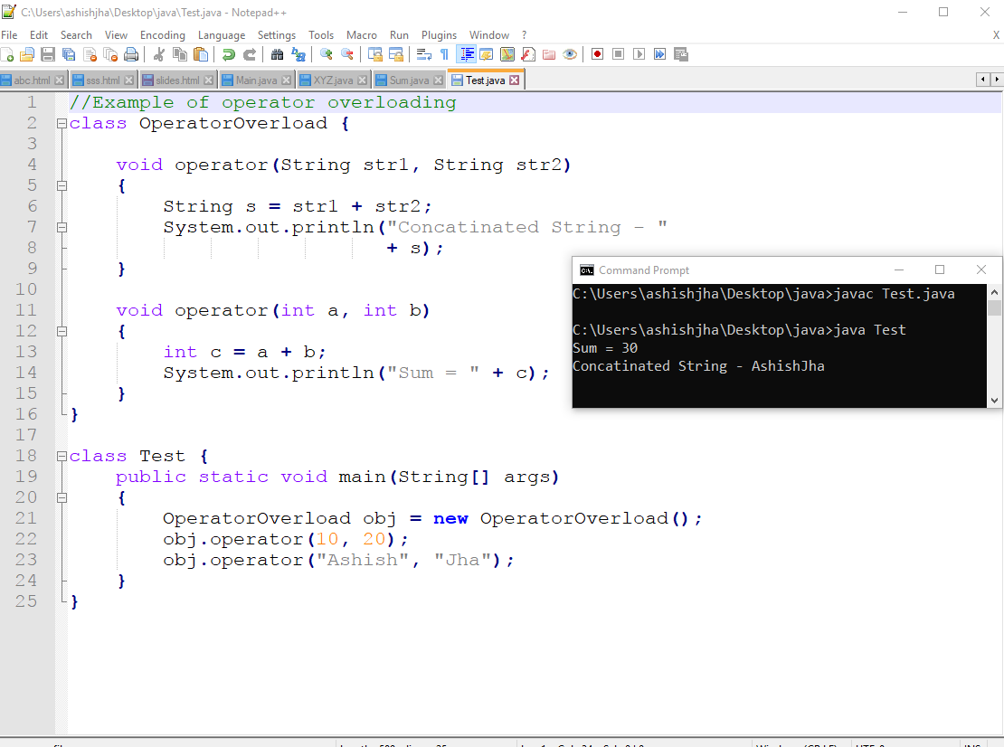

Example:

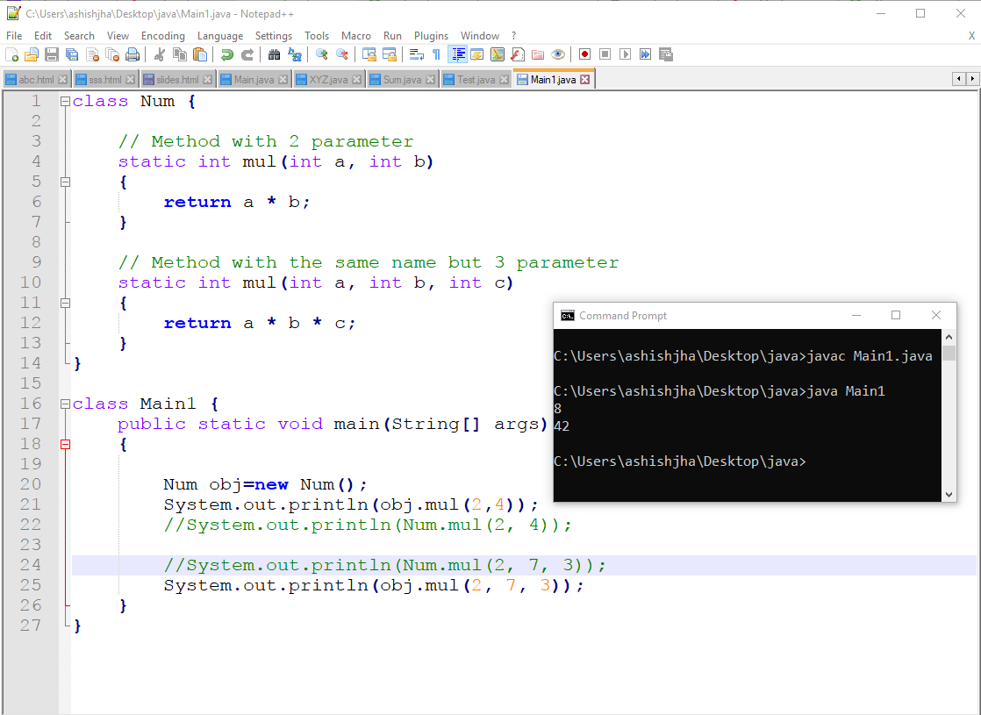

1. [**Runtime polymorphism**](https://www.geeksforgeeks.org/dynamic-method-dispatch-runtime-polymorphism-java/)**:** It is also known as Dynamic Method Dispatch (dynamic polymorphism). It is a process in which a function call to the overridden method is resolved at Runtime. This type of polymorphism is achieved by Method Overriding.

* [**Method overriding**](https://www.geeksforgeeks.org/overriding-in-java/), on the other hand, occurs when a derived class has a definition for one of the member functions of the base class. That base function is said to be **overridden**.

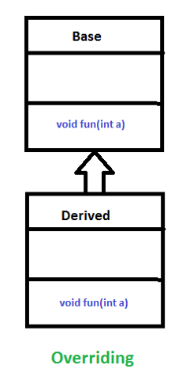

Example:

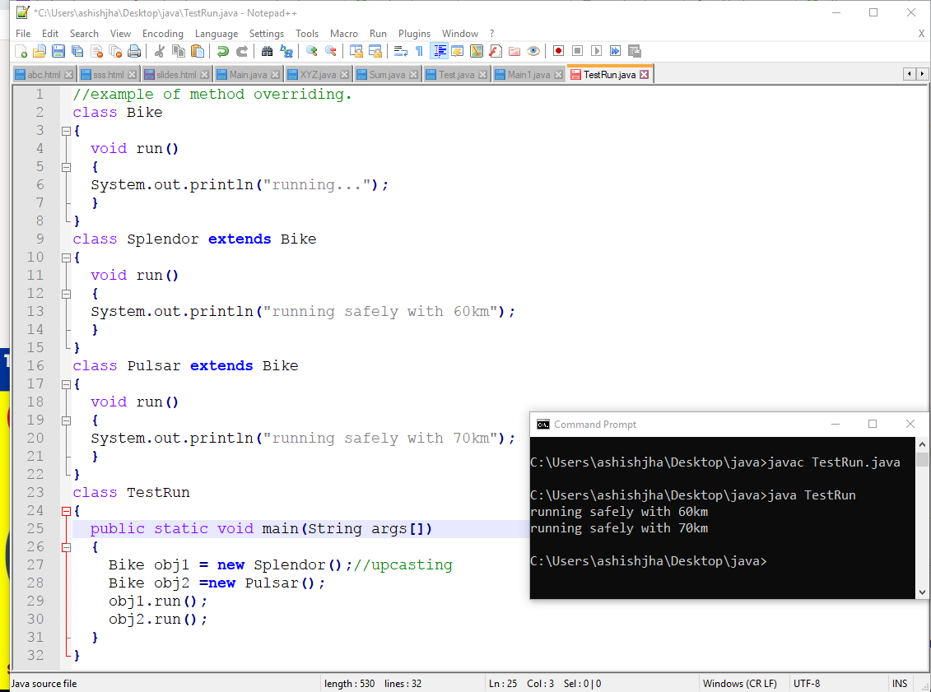

Example:

